UNITED STATES OF AMERICA
BEFORE THE
FEDERAL ENERGY REGULATORY COMMISSION

Ensuring Sufficient Capacity Reserves ) Docket No. EX01-1
In Today’s Energy Markets )

Enron Power Marketing, Inc.’s AND

Enron Energy SErvice INC.’s Comments

on Ensuring adequate capacity

On September 28, 2001 the Commission requested comments on new ways to ensure sufficient reserve capacity. Enron Power Marketing, Inc. and Enron Energy Services, Inc. (collectively, “Enron”) submit these comments.

BACKGROUND
Enron Power Marketing, Inc. (“EPMI”) is an affiliate of Enron North America Corp. (“ENA”) and was formed to develop a North American merchant services business in electric power. Drawing on ENA's experience in the development of a commodity market for natural gas, EPMI has developed a range of products and services related to the purchase, sale and delivery of electric power and the management of associated price risks. EPMI markets these products throughout the United States. EPMI functions as a power marketer pursuant to a Commission order issued December 2, 1993. Enron Power Marketing, Inc., 65 FERC ¶ 61,305, order on reh’g, 66 FERC ¶ 61,244 (1994).
Enron Energy Services, Inc. (“EES”) is a leading provider of natural gas and electric power to the commercial and retail markets in the United States. In addition to making retail sales of natural gas and electricity, EES offers a broad range of energy products, capital, technology and related service capabilities, such as demand side management designed to decrease energy costs, consolidated billing, and related energy asset management. EES is an indirect, wholly-owned subsidiary of Enron Corp., one of the world’s largest publicly-held integrated energy companies. EPMI and EES are referred to collectively as “Enron”.
Additionally, attached is an affidavit of Larry E. Ruff, PhD.
EXECUTIVE SUMMARY
Enron opposes the continuation or implementation of installed capacity requirements. Four appropriately sized Regional Transmission Organizations (“RTOs”) that encompass robust, competitive spot markets for energy and operating reserve products (including demand side management products) will provide an efficient and timely solution to incent construction of adequate generation, the siting of appropriate transmission and efficient use of demand side management products to ensure that demand is met in real time. Spot markets reveal the cost of procuring (or not using) electricity based on actual supply and demand conditions and, thus, signal the need for new generation capacity. They also ensure that consumers ‘see’ the cost of procurement decisions through transparent spot market processes and adjust demand based on discovered prices. These markets will keep supply and demand in balance in both the long and short run without the use of artificial planning criteria. Therefore, there is no need to continue separate installed capacity requirements in an RTO environment.
The use of the spot market to establish pricing for all energy products is new to the electricity industry. Regulated consumers have historically paid utility tariffs that reflect regulatory decisions. These regulated tariffs provide little, if any, meaningful supply/demand price information to the consumer so the response has been to consume even during times when the underlying “cost” of doing so has been high. As a result, demand curves have been categorized as ‘inelastic’ or ‘vertical’ suggesting the need for ‘capacity’ related products to meet any unexpected price insensitive demand. The creation of RTOs and the resulting spot markets they include will, for the first time, give consumers the means and incentive to change the shape of their demand curve as a result of direct real time pricing information. Changes in the shape of the demand curve will in turn eliminate the need for specific capacity related payments as supply/demand interaction, and curtailment, will be based on economic choices.

COMMENTS

I. Importance of RTOs

The most important fact to consider in evaluating alternatives to current capacity constructs is the Commission’s decision to establish four RTOs nationwide (outside of ERCOT). Enron fully agrees with this decision. Establishment of appropriately sized RTOs with real time spot markets will provide the incentives to build generation in a timely manner (as well as provide the basis for alternative solutions, such as transmission siting and demand side management). A well functioning RTO will provide many benefits to the electricity grid of the United States: increased reliability through increased coordination and improved real-time pricing; flexibility and diversity of supply; better ability to identify and price true transmission constraints (rather than artificial, institutionally created constraints); greater capability to minimize energy costs through incorporation and pricing of real constraints in dispatch; more ability to provide better price signals that encourage demand side management; and greater incentive to invest in transmission where warranted. These benefits will bring confidence in the market to attract more participants and market activity and to ensure that capacity adequacy is achieved.
An appropriately sized RTO that is centrally coordinated and operates (or at least assures the existence of) efficient spot markets in energy, ancillary services and transmission capacity can improve the security, reliability and economic benefits of the grid by providing an independent coordination process between operators and generators, and by facilitating market liquidity through hub trading and real time information. This central coordination and efficient pricing advances security and reliability through the ability of the RTO to make decisions based on regional data, rather than the current decentralized decision-making. Reserves can be managed and priced on an RTO-wide basis, rather than by control area, providing the RTO a greater ability to reliably and efficiently transmit electricity from location to location, while increasing reserve sharing and reducing total reserve requirements. Moreover, the grid itself will be improved as capital is invested based on increased knowledge of locational and operational requirements, real time market supply and demand information, and prices that the RTO will provide. Moreover, the RTO will be able to provide greater system security and reliability through this coordination process due to the ability to react more quickly utilizing a much wider supply as well as to take advantage of demand diversity. All of these positive results of an RTO will facilitate investment in generation capacity.
Accurate real time nodal prices that result from the interaction of all market participants will provide the essential price signals to best determine the location and necessity of new investment in generation, transmission, and demand side management. For the first time, consumers will ‘see’ the price effects of consumption and be able to change the shape of or curtail demand in response. This demand elasticity, which is seen in every competitive sector of the United States economy, is new to the electricity market and will eliminate the need for incentive based capacity payments, such as ‘icap’. Individual demand participants, acting directly or through a retail load aggregator, will be able to choose whether to consume during times of high prices or not and receive the resulting economic benefits.
In summary, the stated purpose of capacity products, such as “resources”, “icap”, “reserves” or any of the other names/procedures used across the country, will by achieved by the implementation of RTOs and efficient spot markets in energy, ancillary services and transmission capacity. Therefore, Enron urges and supports the Commission in its effort to continue the implementation of the RTOs and to achieve the goal of well functioning markets in the entire United States.

II. Spot Markets and Capacity Payments.
Capacity payments are a supplemental fee paid to generators to purportedly ensure they provide a sufficient level of generation “capacity”, or generation “reserves”, for reliable operation of the power system in real time. They come in different forms ranging from icap, which is an explicit payment for capacity, to a reserve margin requirement: all implicitly increase the cost of wholesale electricity. However, properly functioning icap markets are difficult to design as they are subject to manipulation and market power (e.g. economic withholding of icap from the bilateral market as suggested by FERC in “Ensuring Sufficient Capacity Reserves in Today’s Energy Markets”, Study Team Discussion Paper).
Historically, capacity payments and reserve requirements have been treated exclusively from a supply side perspective. This is not unexpected, as the wholesale electricity market has been tightly regulated. Consumers have not made pricing decisions: regulators have been responsible for making these decisions for them.
As a result, negotiations between regulators and incumbent utilities focused on ensuring that the power system has enough generation capacity to meet peak demand, with adequate reserves to guarantee a minimum level of reliability if parts of the electric system fail. The capacity adequacy planning process and the mechanism to incentivize and remunerate those reserves was entirely focused on supply side solutions. Other than under emergency situations, demand side solutions were not perceived as a “viable” alternative.
In this environment, reserves were considered a “public” good and property rights for “reserves” were ill defined. Procurement of capacity reserves in this context can be thought of as a tax on consumers to ensure adequate inventory of “MW capacity” to meet real time demand. As a consequence, reserves could not be priced by the market and decisions about capacity adequacy and price had to be managed centrally. During curtailment, all loads would suffer the physical consequences of outages, irrespective of their contracting level. Therefore, there seemed to be no incentives for any individual market participants to manage their need for reserves (or consider their appetite for demand side management). This resulted in the classical “ free-ride” problem.
This mindset was based on a perception of minimal demand elasticity, as shown in the following graph (Figure 1).
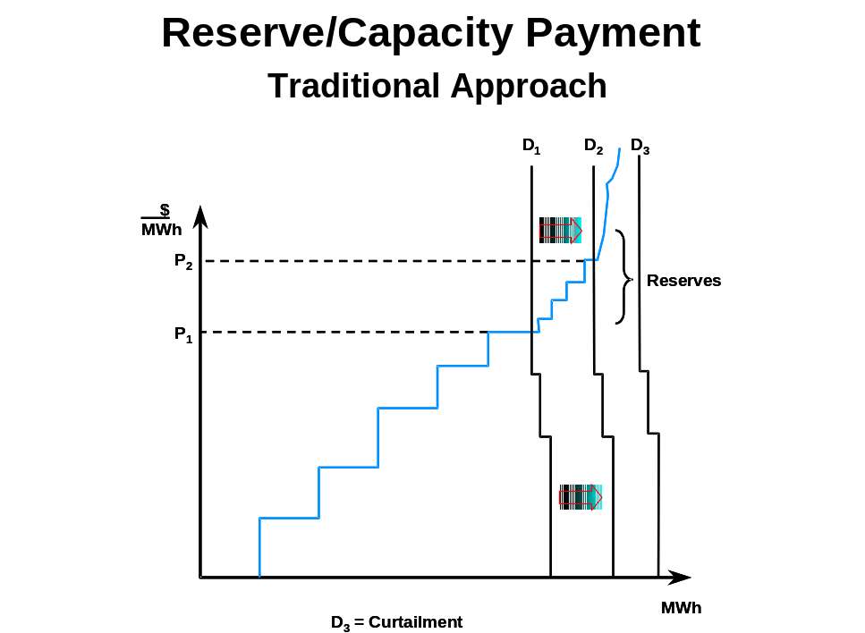

Figure 1

\

During off-peak periods (Demand D1), substantial competitive resources are available and the market clears at spot price levels (P1). However, as demand starts growing (from D1 to D2) spot market prices increase. If demand continues to grow, the spot price is determined by the last segments of a steep supply curve. If demand grows beyond the ability of the market to supply, load will be curtailed as represented by demand curve D3. Historically in some instances, spot clearing prices reached a level that triggered a political response in the form of price caps. The expedient approach for both regulators and suppliers to guarantee that lights stayed on was to introduce explicit capacity adequacy payments and/or cost recovery mechanisms through rates where reserve margins were required.
III. The Need for Demand Side Management
As noted above, historical capacity and reserve approaches have been based on the assumption that the demand curve is inelastic or near vertical. This assumption is incorrect. This is not a radical discovery, it simply reflects basic economic theory and the evidence that abounds in the wider deregulated United States economy: consumption behavior responds to price signals. However, in the electric sector, customers have systematically been shielded from “seeing” and therefore “acting upon” price, which confirmed, at least on the surface, the assumption of limited demand elasticity.
Simply put, the issue of reserves and capacity payments has to be viewed from both a supply and demand perspective. As a result, Enron encourages the Commission to take a fresh look at the reserve/capacity problem, and utilize the solution that RTO structures offer -- spot markets.
A. The Introduction of Demand Elasticity through DSM
The need for capacity adequacy payments, separate from spot market payments, is eliminated as demand elasticity is introduced. This is illustrated in Figure 2. In simple, practical words, consumers reduce consumption (or interrupt their loads) as prices go above a certain level (different consumers make different choices about price levels). This summer, New York’s demand side management programs provided 600 MWs of peak reduction. Empirical evidence in other deregulated wholesale electricity markets show that this is a workable and feasible proposition. The same evidence has shown that with proper telemetering and switching systems, load response is virtually instantaneous!
When demand becomes elastic, interruptible load becomes a surrogate for reserves. The market clearing price will reduce not only because demand is less steep, but also because marginal reserve providers will face more competition. However, this change in the competitive equilibrium is unlikely to ‘hurt’ suppliers of reserves, it simply provides a market signal on the level of reserves necessary to achieve a certain reliability level. In contrast to Figure 1, Figure 2 shows that as a result of demand response to price, the window or “range” of actions between “reasonable” spot prices and curtailment widens significantly allowing suppliers of reserve and demand side bidders to actively participate (and compete) to provide system reliability.

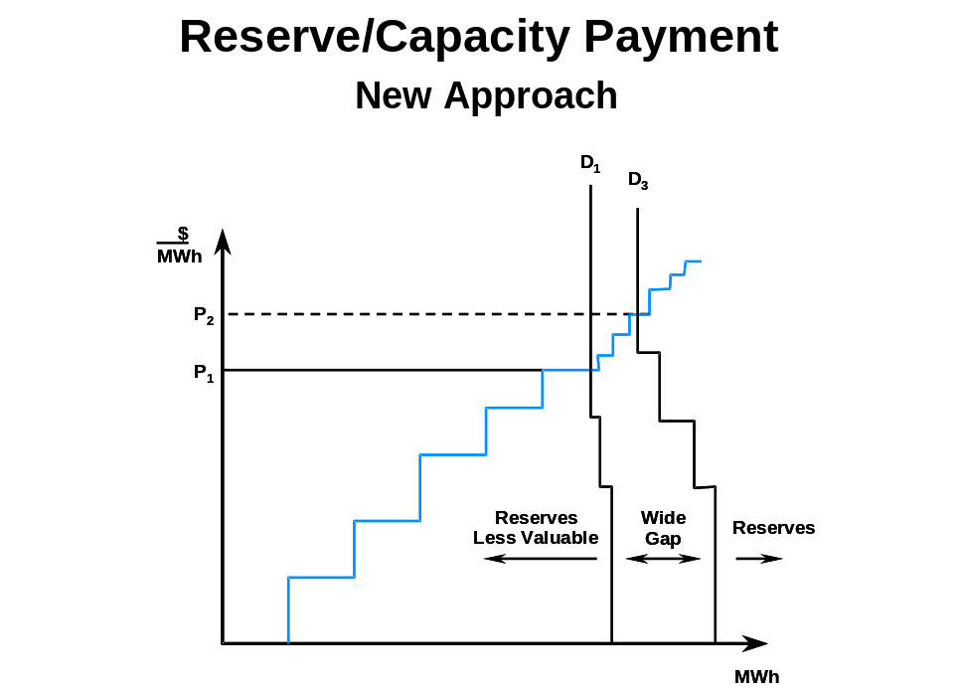

This enables regulators to deal with reserves and reliability as a “market-driven” issue. Consumers, unwilling to face high spot prices, will likely increase their contracting levels or change the shape of their demand curve by “offering” a significant part of load as interruptible. Similarly, less reliable generation plants, which experience unexpected outages will also be willing to contract for reserves. Reliability becomes a “product” with an economic value attached to it. The case for reserves as a public good, and “free riding”, disappears. As a corollary, the case for market intervention, either by capping spot prices or “administering reserve solutions” weakens as well.
This recognition also brings wholesale electricity markets closer to the competitive economy by making reliability (and by implication, reserves) an economic decision. Each player will make contracting decisions to avoid undue exposure to the spot price and spot price trends, coupled with liquid forward markets, will provide price signals for new investments in reserve and capacity.

IV. Transition to Robust Spot Markets – Capacity Payments on an Interim Basis

Enron recognizes that the United States is currently transitioning from a tightly regulated structure to such a competitive structure. While the RTO market structures and price mechanisms mentioned above will incentivize participants to make choices about the necessary level of capacity to be installed and for those participants to invest capital in resources, there is likely to be concern by some that such competitive structures may result in political sensitivities in the short run. These concerns are at worst transitional issues, and at best can be managed through education now, as other segments of the competitive economy manage such issues without attracting political attention.
We also recognize the Commission has in the past been reluctant to eliminate the icap requirement altogether in regions where an icap product already exists. One of the concerns cited by the Commission is the potential disruption of existing forward contracts. Another concern cited has been reliability. While the implementation of RTOs will adequately address the reliability issue, the goal of avoiding undue disruption of forward contracts may support a limited transitional period during RTO formation in which icap requirements are retained, but only in regions where they presently exist and only until a date certain. Enron submits that an appropriate transition period should be no more than two years. This will balance the need to allow sufficient time for existing forward arrangements to either clear or be restructured against the enormous inefficiency costs an icap requirement imposes on consumers. Moreover, to foster demand responsive programs in the interim, Enron recommends that any icap program make the same capacity payments available to verifiable interruptible load. Such payments can help foster interruptible demand during the period to a full real time market price. If the Commission seeks to implement or amend existing markets as an interim step, Enron sets out an interim approach in Appendix A that it believes minimizes market distortion.

CONCLUSION
Enron encourages the Commission to fully consider the economic benefits of this solution. Robust spot markets that encourage efficient and timely supply/demand responses eliminate the need for separate capacity payments.

Respectfully submitted,

_____________________________
Christi Nicolay, Senior Director
Enron Corp.
1400 Smith St.
Houston, Texas 77002
713-853-7007
713-6476-8160 (fax)

Sarah Novosel, Senior Director
Enron Corp.
1775 Eye Street N.W.
Washington, DC 20006
202-466-9160
202-955-8496 (fax)
UNITED STATES OF AMERICA
BEFORE THE
FEDERAL ENERGY REGULATORY COMMISSION

Ensuring Sufficient Capacity Reserves ) Docket No. EX01-1
In Today’s Energy Markets )

CERTIFICATE OF SERVICE

Pursuant to Rule 2010 of the Commission's Rules of Practice and Procedure, I hereby certify that I have this day caused a copy of the foregoing document to be served on all persons designated on the service list compiled by the Secretary and the restricted service list in these proceedings.

Dated at Washington, D.C., this ____________________,2001.

___________________________
______________________
Appendix A
A - Forms to pay for reserves and to achieve system adequacy
As Enron stated above, the spot price alone is the best signal for the market to determine system adequacy and remunerate for required reserves. However, when regulatory intervention is perceived to be needed, there are many ways to achieve the overall goal of long run capacity adequacy and payment for required capacity reserves. For explanatory purposes, those can be grouped into two basic models:
- Model # 1 – Determine a “spot price” for reliability and the market will get adjusted to the embedded system adequacy level
- Model # 2 - Determine a system adequacy target and the market will provide a price for capacity reserves
Model # 1 has been used in the UK and in many other countries for quite a long time. According to this model, the spot price is comprised of two components: the first is the short run marginal cost (SRMC) determined from the offers of generators (and any load that bids into the pricing mechanism) and the second component is an explicit payment for capacity, called “capacity fee”. All imbalances are settled at this two-component spot price. The capacity fee is an extra spot payment paid by the load and received by all generators that either generate or make themselves available to generate, if necessary.
In concept, the spot capacity payment or “adder” is based on the power system reliability (or lack thereof) as measured by the Loss of Load Probability (or LOLP). LOLP measures the likelihood that the existing generating capacity (including reserves) at any moment in time will not be able to meet peak demand conditions, therefore causing a supply interruption. The more reserves a power system has, the lower LOLP is going to be. The payment to reserve capacity, which varies on an hour-by-hour basis, depends on how much customers are willing to pay to avoid interruption. This is measured by the so called Value of Loss Load (or VLL). The multiplication of VLL by LOLP, at any give point in time, represents approximately the payment to be made to generators. VLL is a parameter set “administratively”, and is meant to be a proxy for the average customer’s maximum willingness to pay to avoid curtailment.
In practice, the function determining how the level of the spot capacity fee or adder depends on system conditions will be determined pragmatically. The critical components are that: (i) the spot energy-plus-capacity price increases to some high VLL point if load actually is shed due to generation inadequacy and increases “almost” to this level when load is “almost” shed, i.e., when operating reserves are dangerously low, and (ii) the spot capacity fee or adder be essentially zero during hours when there is plenty of capacity available to provide energy and operating reserves. If the spot capacity fee meets these criteria, the level of reserves will be adequate and will be determined by the market, based on the market participants’ supply/demand forecasts. Producers will use resulting forward curves to determine when and where it is appropriate to build new capacity. In this scenario, no reserve requirement obligations are imposed on load serving entities.
Model # 2 assumes that a certain “quantity” of reserves will be defined. According to this model, a regulatory entity will define a certain “reserve requirement” which should be consistent with reliability and system adequacy targets. In the United States, it has been usual to adopt a LOLP of 1 day every 10 years and reserve requirements of about 15-20%. This calculation represents an approximation, since it depends on system configuration and demand forecasts. This reserve requirement is usually imposed on load serving entities. In theory, reserve providers will invest in additional capacity up to the point that the reserve requirement is met.
This model has been used in the US. However, the application of this model varies a lot across different power pools and regions. Even for contiguous power pools, with significant power interchange and sharing of reserves, the approach to the reserve capacity problem varies a lot. For example, in the recent mediation ordered by FERC on July 12 for the Northeast, involving Nepool, NYISO and PJM, it became clear that:
- There are significant differences in how each pool handles the reserve requirements and payment processes. Not only do the NYISO, Nepool and PJM processes differ, PJM itself uses two methods, one in PJM and another in PJM West.
- In all power pools, the topic of capacity payments (icap) has been subject to intense debate. The methodologies are in state of flux.
- There is no such a thing as a single “benchmark”.
- The multiplicity of approaches does not allow adjoining power pools obtain maximum reliability for the existing system; nor does it allow vibrant trading activities across those power pools.
Neither approach is perfect, they are simply regulatory fixes to what otherwise would be resolved through competitive solutions. However, if an interim approach is deemed necessary, Enron sets out a proposal below.
B - Enron’s Interim Capacity Approach
Enron has three specific difficulties with icap proposals as implemented today. First, implementation differs from pool to pool. Second, icap can create a barrier to entry, and third, it is unnecessary as we note in the main body of the text above. An interim proposal to amend icap payments needs to resolve the first two issues. A finite interim term, such as 2 years, will achieve the last.
As icap is implemented differently from region to region, resources have differing incentives and abilities to provide the product. For example:
- In PJM, reserve providers are more likely to sell their resource outside of PJM at the very times it is required due to the price caps in place.
- In NYISO, not all external resources are allowed to sell in NY – resources located in NEPOOL are excluded.
- The processes and timelines that the security coordinators use to procure capacity resources differ. This makes it difficult to procure resources from other regions in much the same way that scheduling transactions between control areas is complex.
Therefore, the first requirement of any interim icap approach is that a standardized market and product must be applied across all regions.
Icap markets can also sustain commercial barriers to market entry because procuring icap resources is a complex task for third party competitors. Incumbents that have historical obligations are able to bilaterally contract with internal resources in order to meet any obligation. This task is more complex for third parties, as in most regions with capacity markets a participant must show that it has met the icap requirement by nominating its icap resources in the day ahead market. If the participant does not meet this obligation, it faces penalty payments. This forces participants into bilaterally contracting with generators who are potentially their competitors. The simple solution to this problem is to identify icap for what it is – a public good . As a result, the cost of icap should be charged initially to the transmission owner (or party that bills for transmission service) who then allocates the cost to all parties servicing consumers as a flat tax. For example, if the cost of procuring icap within a region is $1 billion per year, the cost is divided by the gross consumed MWh for the previous year and charged as a fixed rate to all consumed MWh in the current year (any over/under recovery would be offset/funded by next year’s cost allocation mechanism).
Therefore, the second requirement is that the interim icap requirement must not add barriers to entry, rather it should be recognized as a public good and allocated to all consumers.
Enron’s approach below accommodates these two elements and is based on the second model described above. It is based on this model because, as an interim approach, it will only exist for up to 2 years. So, while model 1 possibly presents a more robust approach, the costs of implementing it likely outweigh the benefits.
The aggregate icap quantity required should be the sole purview of the RTO. The RTO is the one that has all the information on load forecasts and installed resources and is the one that performs the necessary analysis to determine reserve margins and obligations. For example, in PJM, the staff would perform all calculations in terms of reserve requirements, and present the results to the Reliability Committee for approval, which would typically be approved unanimously.
The RTO should therefore determine the annual icap obligation, then conduct an annual auction for the necessary resources and load curtailment bids. This would be a similar process to the RTO’s involvement in determining revenue feasibility for financial transmission rights and LMP price setting processes – it receives bids, stacks them, determines the clearing price, and dispatches according to the stack. It would be the same for the icap auction. The RTO would not be a participant in the market as such and is only the facilitator.
The total cost of icap would then be allocated to the load serving entities or transmission owners (any entity that charges for customers for embedded transmission) based on a pro-rata share of aggregate annual cost from the previous year (by dividing the cost by total consumed MWh). They would in turn recover the cost from load (by charging each consumed MWh the derived cost) as a part of their revenue requirements (ideally it would appear as a separate line item on an end users bill and be identified as a "reliability tax" so they would see what it is costing them).
This proposal, would accomplish the following:
1. It would satisfy the reliability concerns of all participants.
2. It would assess a "tax" on the load for reliability. This both reflects the nature of the product and recognizes that load is the beneficiary of reliability.
3. It would relieve the LSEs of the burden and obligation of providing icap,
4. Deficiency penalties would not be required and accompanying deficiency rates would not need to be determined,
5. Generators would still receive icap income, provided they are selected in the auction,
6. Since the icap obligation is typically for a period in the future (in PJM, the icap requirements approved this year are for the year 2003), the much talked about "price signal" for new generation is provided,
7. It allows the market to set the icap and not some artificial deficiency rate,
- Market power issues associated with the existing icap markets are eliminated,
- It is simple to implement and administer, would not result in cost shifting and is consistent with the current approach to identifying icap requirements, and
- It is easy to remove at the end of the interim period.

Operating reserve products will still be required.
Nowhere has the subject of icap been more controversial than in New England. From November 1998 through August 2000 ISO New England administered a bid-based auction market for icap. The results were disastrous and led the ISO-NE to seek FERC authorization to eliminate both the icap auction market and the icap requirement altogether. This request was based on the ISO-NE’s belief that prices in that market reflected an exercise of market power. Order Conditionally Accepting Congestion Management and Multi-Settlement Systems, 91 FERC ¶ 61,311, at 62,080 (June 28, 2000). With respect to the auction market for icap, the Commission agreed with the ISO-NE in finding that “the existing auction is not useful and that it can produce inflated prices unrelated to the actual harm created by icap deficiencies.” Id., at 62,081. The auction market was thereafter eliminated on August 1, 2000. With respect to the icap requirement itself, however, an icap obligation has been provisionally retained by the Commission. This has required the Commission to conduct extensive proceedings to establish a deficiency charge for failure to procure icap requirements in the bilateral markets. Because the bilateral markets are unmonitored and because the deficiency charge is a highly artificial figure, the establishment of this charge has proven very controversial, requiring protracted proceedings before this Commission as well as the United States Court of Appeals for the First Circuit. Throughout the controversy, however, the Commission has consistently looked to New England to develop a better reliability assurance mechanism than the outdated icap requirement. In that regard, the Commission has consistently pointed New England toward examination of a forward reserve requirement as an alternative to icap. “To the extent that forward reserve purchases take the place of proposals for an icap market with a deliverability requirement, this may prove to be a workable design alternative.” Id., at 62,067. See also Order on Proposed ICAP Deficiency Charge, 96 FERC ¶61,234, at 61,942-43 (August 28, 2001) (“We will also direct ISO-NE to file, on or before December 3, 2001, a compliance report in this proceeding regarding alternatives to the icap requirement, particularly the feasibility of a program of acquiring forward reserves and using demand side mechanisms to meet ISO-NE’s reserve capacity needs.”) To date, however, neither NEPOOL nor ISO-NE has come forward with such a proposal.
Other examples of how icap and reserve market design can distort prices for consumers is provided by a recent study by Citizen’s for Pennsylvania’s Future (PennFutures E-Cubed) that shows that Duquesne Light “…will be charged $45 million per year to meet PJM West’s new capacity requirement called ACAP…” Duquesne is moving from ECAR where there is only an operating reserve requirement and no price caps to PJM West where there are price caps and an ACAP, with no discernible improvement in reliability.
While spot markets were not typically in use, hypothetical supply demand curves can be derived.
Typical supply/demand interaction.
This is entirely rational commercial behavior. As the last suppliers in the stack must recover their return on capital and costs over a very limited timeframe, prices during these time periods would naturally increase.
However, price caps fortunately have not been used each time the spot market reacted to a supply shortage with high spot prices. For example, there was no regulatory intervention in the ECAR markets in response to the price spikes of 1998. As a result, the market responded with the addition of generation.
Contrary to the claims made by icap proponents, the lack of an icap market was not the cause of the sustained price excursion or reliability problems in California. Instead, these problems were caused by the lack of the ability to adequately site generation, coupled with a retail market structure that shielded customers from wholesale price signals. The large majority of reliability problems (blackouts) were caused by credit problems and not any sort of shortage of physical supply. When retail rates were raised in June 2001, demand response finally occurred and the wholesale price of power dropped.
Samuelson, P. and Nordhaus, W. Economics. Irwin McGraw-Hill, 1998.
In 1996 New Zealand deregulated its wholesale electricity market. The resulting market framework did not include any long run capacity adequacy related payments, yet it has seen the addition of timely resources to meet expected capacity requirements. (See www.m-co.co.nz). In addition, this concept has been proven to work in numerous capital intense sectors of the competitive economy. Examples include petrochemical, petroleum and IT related industries. These sectors are all critical industries that ensure a robust US economy.
Those consumers that require high levels of reliability will be specifically incentivized to do so to avoid spot market price spikes. This is unlikely to be a new or onerous task for these consumers as most of them are likely used to managing such price risks as they buy/sell in competitive markets themselves. This solution will also allow customers that do not need high levels of reliability to offer the market “negawatts” benefiting system reliability. Even small customers can participate through their LSEs.
The evidence from New Zealand suggests that both large industrial customers and retail aggregators enter into contracts to interrupt. Interruptible load is now a material component of that market’s dynamics.
Producers do not need to be incentivized through explicit payments to build capacity. They will make economic decisions about when, what and where to build plant to supply the market with a product that consumers are willing to buy. All competitive industries, capital intensive or not, solve this issue in similar ways. There is an explicit belief that suppliers will supply product if consumers are willing to pay them for it. [Even residential food supply, which is at least as ‘essential’ as electricity, is managed via competitive solutions rather than by imposing capacity requirements].
, The current icap mechanism in New York, which includes deficiency penalties, costs New York consumers approximately $2 billion annually.
In New England this deficiency charge has been the center of controversy. See 96 FERC 61,359.
The situation is further affected by the processes used by each region that make it difficult to procure capacity from outside the region to meet the obligation.
Where icap is specifically separated from energy, it is by definition a public good. As such, the cost of the product should be recovered from as many participants as possible in a manner that minimizes distortions (i.e. by taxing participants).
Successful tenderers (which would include both generation and demand side management) would have to complete scheduled maintenance in the off peak season (schedule to be approved by the RTO), make offers into the spot market for every trading period over which they are contracted and face penalties if they fail to generate when called to operate. In order to ensure that the capacity resources are able to generate when called, the RTO would be able to order operational tests on capacity resources twice yearly. For example, when a gas-fired peaker is called to operate, the capacity must be ‘brought online’ within 15 minutes of the issue of the instruction (failure to meet comply with such tests would result in liquidated damages payments).

